**PROJECT REPORT**



**ON**

**“ MEDICAL**

**MANAGEMENT SYSTEM”**

**SUBMITTED TO**

**P.A.H. SOLAPUR UNIVERSITY, SOLAPUR**

**FOR THE FULLFILMENT OF AN AWARD OF**

**BACHELOR OF COMPUTER APPLICATION**

**SUBMITTED BY**

**Miss. Prachi Maruti Bhosale**

**UNDER THE GUIDANCE OF**

**Prof. Tathe P.B.**

**THROUGH**

**NEW SATARA COLLEGE OF B.C.A, PANDHARPUR**



**2024-2025**



I Certified that project work report titled **“MEDICAL MANAGEMENT SYSTEM“** has been completed satisfactorily in partial fulfillment of **B.C.A course** of the P.A.H.SOLAPUR UNIVERSITY, SOLAPUR for the Academic year 2024- 2025 by the following Student of New Satara College of B.C.A, Pandharpur.

**.**

Place: Pandharpur

Date: Head of Department

(New Satara College of B.C.A, Pandharpur)

Checked by

External Examiner Internal Examiner

**DECLARATION**

We undersigned declared hereby that the project entitled “**MEDICAL** **MANAGEMENT SYSTEM”** developed in **“PHP & Microsoft SQL”** submitted by us is an original work. The project presented is developed by us independently and is not duplication from any other source. We understand that there is any copying such is liable to be punished in any way the University authorities deem it.

The work is here by submitted to P.A.H.Solapur University, Solapur for the Degree Bachelor of Computer Application

Place: Pandharpur

Date :

**Miss.Prachi Maruti Bhosale**

**ACKNOWLEDGEMENT**

We sincerely thank to all who’s blessing and good wishes have enabled us to complete the task of **“MEDICAL MANAGEMENT SYSTEM”.** We would like to thanks **Prof.Tathe P.B.** for their constant encouragement and invaluable guidance in completing the project.

We express our profound thanks to our project guide and project in charge Prof. Sonule A.P. and also Thanks to all those who have indirectly guided and helped us in preparation of this project.

**Miss.Prachi Maruti Bhosale**

**INDEX**

| **Sr. no** | **CHAPTER NAME** | **Page no** |
| --- | --- | --- |
| **1** | **ABOUT EXISTING SYSTEM**   * Existing System * Problems In Existing System * Need For Computerization | **1** |
| **2** | **PROPOSED SYSTEM**   * Objectives in the Proposed system * Proposed hardware & software * Proposed Hardware * Proposed Software | **2** |
| **3** | **FEASIBILITY STUDY**   * Technical Feasibility * Operational Feasibility * Economic Feasibility * Scope of Proposed system | **5** |
| **4** | **SYSTEM DESIGN**   * Data Flow Diagram * Context Level Diagram * ER Diagram * Data Dictionary * Output Screen | **7** |
| **5** | **CONSTRAINTS &LIMITATIONS OF PROPOSED SYSTEM**   * Constraints * Limitation * Conclusion | **22** |
| **6** | **Bibliography** | **24** |

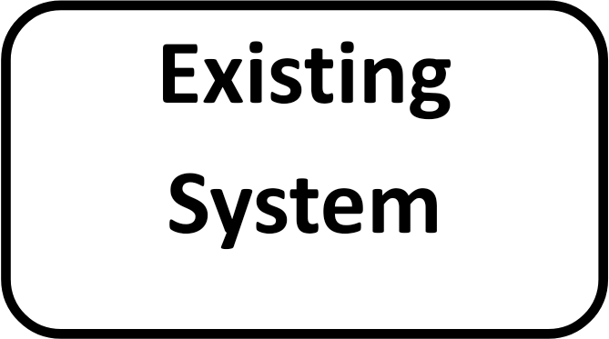



1. **EXISTING SYSTEM DETAILS**

There is no computerized system available. All the work is done manually.



1. **PROBLEM IN EXIATING SYSTEM**

* The existing system is completely manual, it is time consuming
* There are lots of paper work calculation notebooks are carried out existing system
* Sometimes information of data is not stored properly as there is time wastage for finding this record. Some time Financial data loss may be possible
* There are many entries in billing, which is time consuming.
* The maintenance of master in manual is confusing. The need for computerization was felt on following points



1. **NEED FOR COMPUTERIZATION**

* Maintaining data becomes tedious & when done manually.
* All transaction entries are made every day. Maintain these entries are time consuming
* Redundancy of data is to be avoided
* The data being vital to all departments needs Appropriate safety & security
* The generation of report is time consuming. Hence, the bulk of information is very Huge and difficult to Maintain manually. To overcome above draw back backup computer system may help much better and also task done on computer are optimized task .It reduces manual efforts and also storage is not openly like file stored in self. Instead that storage is on the hard disk for building full data in it.

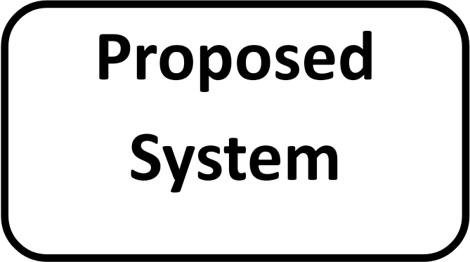

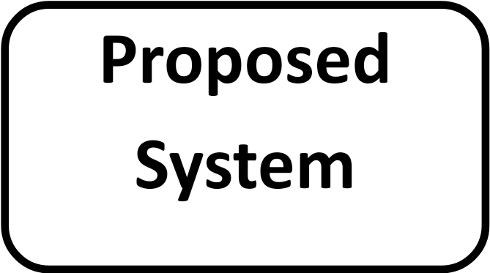

1. **PROPOSED SYSTEM**
2. **Objectives of proposed system.**

**2. Proposed hardware & software platform.**

* + Proposed Hardware.
  + Proposed Software.
  + Justification**.**

1. **Feasibility Study**
   * Technical Feasibility
   * Operational Feasibility
   * Economic Feasibility
2. **Scope of Proposed System.**
3. **Input to the system.**
4. **Output from proposed system.**

**OBJECTIVES OF PROPOSED SYSTEM**

1. Overcome the problem arrived in the existing system
2. To generate error free report.
3. Provide the facility like adding record.
4. Consumer time and effort of daily customer.
5. Avoiding daily customer from corruption.
6. It should provide outputs with maximum accuracy.
7. It should bring flexibility while working with the system
8. To provide the facility like adding, removing & changing the record.
9. To provide various report’s at fingerer tips user.

**HARDWARE AND SOFTWARE PLATFORMS**

1. **Proposed Hardware Platforms-**
   * **Processor Dual Core / Core i3 /Core i5**
   * **500 GB Hard Disk**
   * **8GB Ram**
   * **LED / LCD Color monitor**
2. **Proposed Software Platforms-**

* **Windows 10 /11**
* **PHP**
* **MS SQL**





**Prior to system development through a study of system is carried out which involves following steps.**

1. Identification of organization or user needs.
2. Identification of how different tasks were carried out.
3. Providing technical feasibility of the proposed system.

**Feasibility study has three steps:**

**1. Technical feasibility**

**2. Operational feasibility**

**3. Economic feasibility**

**Technical Feasibility:**

This aspect is always considered to at least important issue. The hardware requirement to support the system is readily available.

1. System is developed by Microsoft visual studio 2010.

2. The system is being friendly, data entry generation is easy.

3. Backup and restore being user friendly, data entry and report generation is easy.

**Operational Feasibility:**

In operational part of the feasibility study, it was determine that the system wills the able to perform the designation function within its current personals & existing processors programmers as required for the end user.

**Economical Feasibility:**

In operational part of the feasibility study, it was determine that the systems will the able to perform the designation function within its current personals & existing processors programmers as required for the end user.

**SCOPE OF PROPOSED SYSTEM**

1. All expected reports are generated.
2. Any future up gradation in the system is possible.
3. The system have user friendly environment.
4. All transactions are maintained up to date.
5. Numbers of queries are used.
6. Stock handled with proper validations.
7. Proper validations are applied (for ex. The quantity field takes only number data).

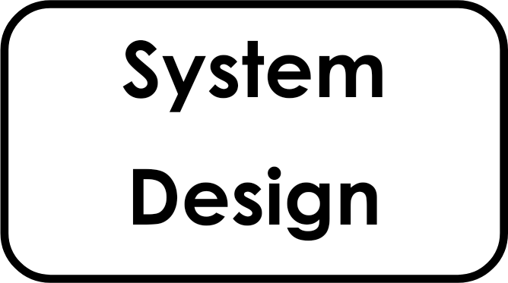



A common view of testing held by user is that it is performed To prove that there is no error in the program. A proper testing & implementation plan is necessary for the success of the system implementation. System testing is critical process which has to be done by every system developer in order to test the program error may occur due to incorrect programming or simply omission in the original design.

The testing plan suggested for the **“MEDICAL MANAGEMENT SYSTEM”.** Is described in details. The strategies are as follows.

**1. UNIT TESTING**

**2. SUBSYSTEM TESTING**

**3. SYSTEM TESTNG**

**1.UNIT TESTING:**

In this type of testing procedure individual program will be tested with respect to desired output from the system .After completion o f some program some test data as per specification will be used for the testing of that program to see if it work as specified. Case will taken while entering the test data so as to check out the of the data element.

**2 SUBSYSTEM TESTING:**

In one system there are many sub system. In this one complete module is treated as sub system & all the program coming under that module will be tested simultaneously with respect to individual performance as well as combined performance & the result or the output obtained will be verified

against the expected or the desired output.

In one sub system of the daily management system will not work properly then it works affect performance of the system as the whole.

**3 SYSTEM TESTING:**

After completion of subsystem testing all the interconnected Subsystem will be tested under this testing procedure. The system will be as whole & not in terms of single module testing or in terms of Individual program testing .This procedure will test the integrity of the data while it transfer one process to another.

For testing purpose necessary test data as per specification is entered & whole system will be tested.







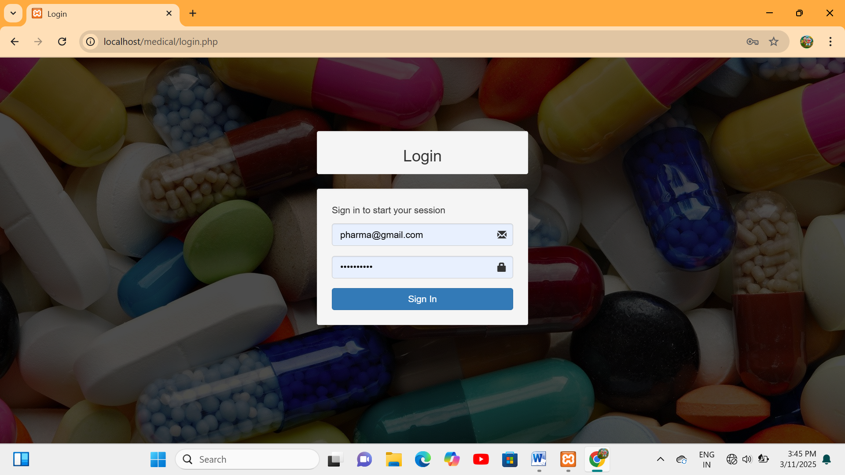



**CONSTRAINTS & LIMITATIONS OF PROPOSED SYSTEM**

**CONSTRAINTS:**

1. The proposed “**MEDICAL MANAGEMENT SYSTEM**“ system is interactive & less time consumable.

2. The system gives result accurate & faster than the manual System.

3. The proposed system gives various reports about system tools.

4. The system is suitable for any organizational store.

5. The system is able to show reordered level, so not necessary to check stock every day

**Limitation:**

1. As there is requirement of computer, the organization should have the computer

2. Skilled person is required in organization

3. In this system we cannot update latest information

**Conclusion:**

By all discussion we can conclude that computerized system developed by me is very useful for the organization. Computerized system reduced lots of paper work. The data can be stored in computer memory and we can take hard copies of data when we want.

The other thing is that by making some changes this software can be used for other organizational store.



**BIBLIOGRAPHY**

For the completion of this system and documentation we have referred the following book & websites

**1. MICROSOFT VISUAL STUDIO C#.NET—RAJENDRA SALOKHE**

**2. A COMPLETE REFERENCE OF C#.NET**

**3.** [**www.stackoverflow.com**](http://www.stackoverflow.com)

**4.** [**www.google.com**](http://www.google.com)

**5.** [**www.codeproject.com**](http://www.codeproject.com)